**Lab 2: Deep Image Prior**

Lab Objective:

In this lab, you will be asked to reproduce the experiments of the paper “deep image prior”.

Important Date:

1. Experiment Report Submission Deadline: 4/10 (Tue) 12:00

2. Demo date: 4/10 (Tue)

Requirements:

* Experiment of figure 2
* Denoising
* Super-resolution

Environment:

Download image:

Sample Code:

Official code:  
<https://github.com/DmitryUlyanov/deep-image-prior>

Lab Description:

* Deep image prior
  + the structure of a generator network is sufficient to capture a great deal of low-level image statistics prior to any learning
  + a **randomly-initialized** neural network can be used as a handcrafted prior with excellent results in standard inverse problems such as denoising, superresolution, and inpainting
  + Parameterization image
  + Inverse problems
    - Denoising, super-resolution, inpainting

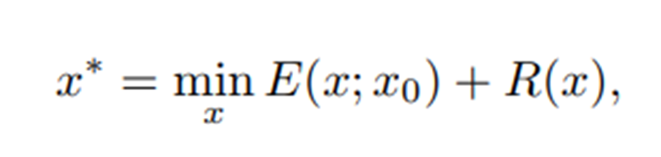

* Let is the prior captured by neural network

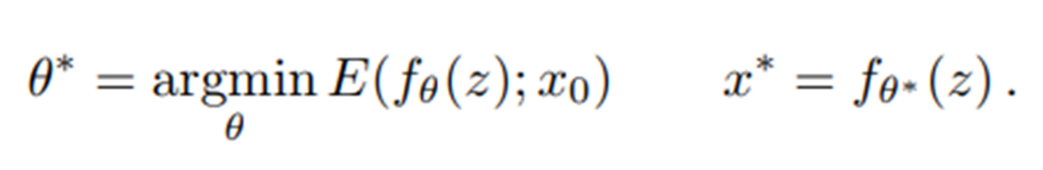

* Requirement 1
  + A parametrization with high noise impedance

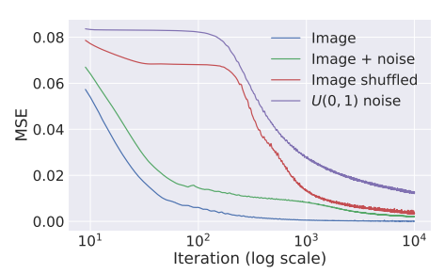

* + Network architecture

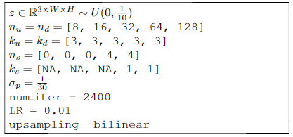

Optimizer: Adam

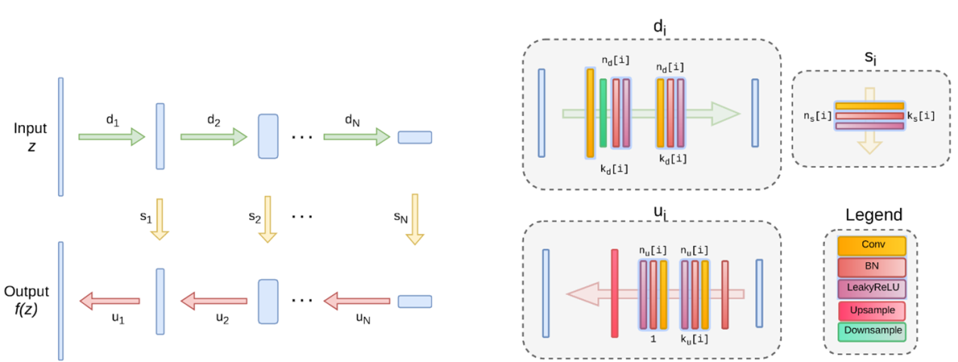

* Requirement 2
  + Blind image denoising

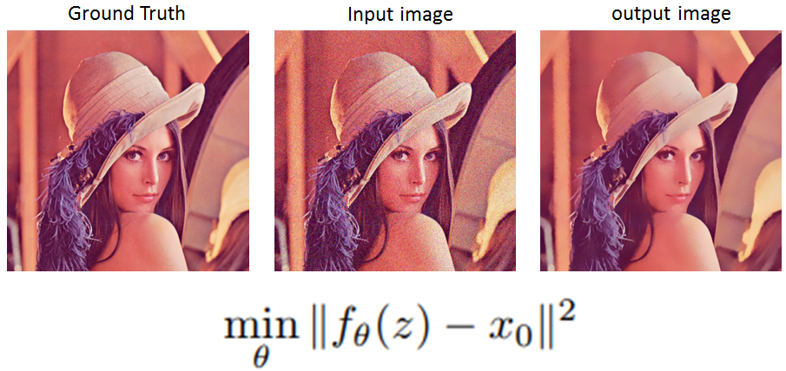

* + Network architecture

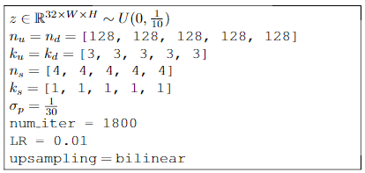

Optimizer: Adam

* Requirement 3
  + Bilnd super-resolution

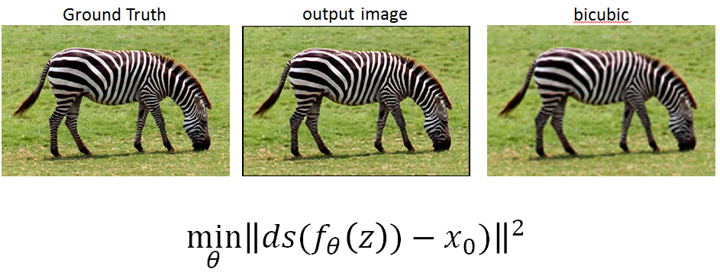

* + Network architecture

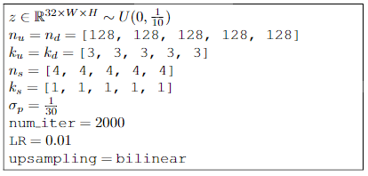

Optimizer: Adam

Extra Bonus (+2):

* Inpainting

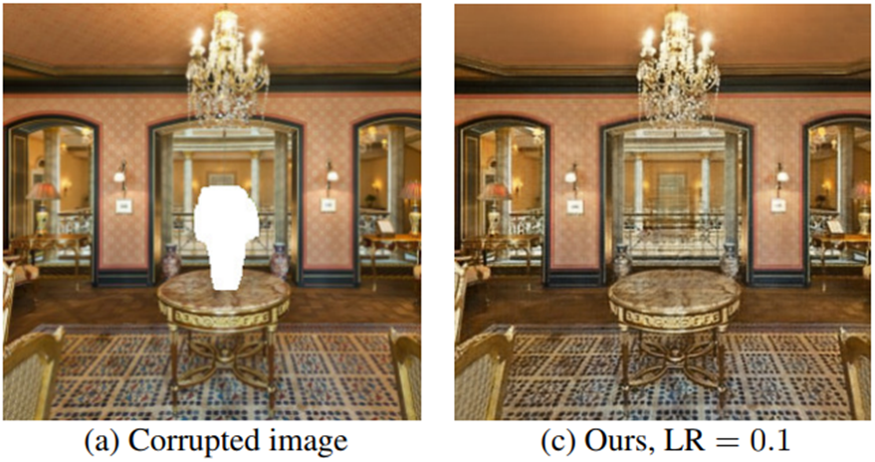



: mask

References:

[1] Ulyanov, D., Vedaldi, A., & Lempitsky, V. (2017). Deep Image Prior. *arXiv preprint arXiv:1711.10925*.

* Report Spec: [black: Demo, Gray: No Demo]
* 1. Introduction (5%)
* 2. Experiment setup (5%)
  + The detail of your model
  + Report all your training hyper-parameters
* 3. Result
  + Requirement 1 (10%, 20%)
    - Training loss curve (you need to record training loss every iteration)
  + Requirement 2 (10%, 20%)
    - Visualize the progress of inverted image
    - Final image and its PSNR
  + Requirement 3 (10%, 20%)
    - Visualize the progress of inverted image
    - Final image and its PSNR
* 4. Discussion (10%, 20%)
* Demo (50%)
* **Demo會給其他圖案，用你的程式重現實驗**

---- Criterion of result (denoising)(20%) ----

PSNR > 30 dB = 100%

PSNR 28.5~30 dB = 90%

PSNR 27~28.5 dB = 80%

PSNR < 27 dB = 70%

---- Criterion of result (super-resolution)(20%) ----

PSNR > 23 dB = 100%

PSNR 21.5~23 dB = 90%

PSNR 20~21.5 dB = 80%

PSNR < 20 dB = 70%

PSNR計算請使用

from skimage.measure import compare_psnr

**評分標準: 40%*實驗結果 + 60%*(報告+DEMO)**